TASK 4:
;Task 4 lab 1
mov eax, 30
mov ebx, 15
sub eax,ebx
call writeint

OUTPUT:
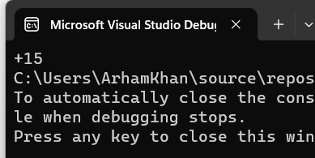
TASK 5:
.data
msg1 db "green lights on",0
msg2 db "red lights on",0
.code
;Task 5 lab 1

mov eax,12d
mov ebx,12d
mov edx, 0

cmp eax,ebx
je L1
jne L2

L1:
mov edx, offset msg1
call writestring
call crlf
call exitprocess

L2:
mov edx, offset msg2
call writestring
call crlf
call exitprocess

exit
OUTPUT:
